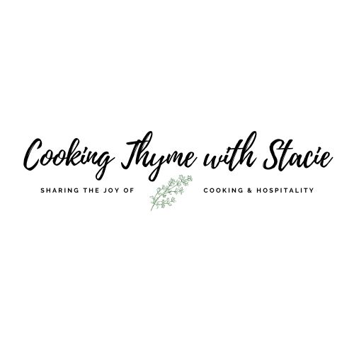

ScienceLogic Heart Healthy Cooking Class

Tuesday, February 11, 2025

MENU

Homemade Granola

Shakshuka with Poached Eggs

[www.cookingthymewithstacie.com](http://www.cookingthymewithstacie.com)

Shopping List

Dairy

* 5 eggs, medium size
* Feta cheese I prefer buying it in a block, not the crumbles)
* Your choice of Yogurt for granola

Pantry

* 4 cups old-fashioned rolled oats
* ½ cup melted coconut oil
* ½ cup honey
* ¾ cup slivered almonds (or nut of your choice)
* ½ cup sweetened flaked coconut
* ¼ cup packed dark or light brown sugar
* 1 TSP vanilla
* 1 TB tomato paste
* 1 (28 Ounce) can crushed fire-roasted tomatoes (I use Muir Glen brand)
* 2 TB olive or avocado oil

Produce

* Cilantro for garnish
* ¾ cup chopped yellow onion
* 1 red bell pepper, seeded and chopped
* 3 garlic cloves, minced
* Fresh berries, if desired for yogurt parfait

Spices

* 1 TSP cinnamon
* Salt and pepper
* 1 TSP smoked paprika
* 1 TSP cumin
* Dash of cayenne

Specialty

* Pita bread or toast

Equipment Needed

Baking

* 2 Large rimmed sheet trays
* Silpat (silicone) mat, which I prefer or parchment paper

Pots and Pans

* 12” skillet

Utensils

* Can opener
* Cutting board
* Chef’s knife
* Ladle
* Measuring cup
* Measuring spoons
* Mixing bowl
* Spatula
* Whisk
* Wooden spoon

Mis en Place  
The French culinary term for “everything in its place”

In order to have a smooth cooking experience, I recommend that you retrieve all the equipment you will need for the class before we begin. In addition, if you have time, group your ingredients by recipe. Most chefs place their components on sheet pans – this is ideal if you have the room.

* Preheat oven to 350˚
* Arrange ingredients by recipe

Homemade Granola

4 cups old-fashioned rolled oats

1 TSP cinnamon

½ cup melted coconut oil

½ cup honey

¾ cup slivered almonds (or nut of your choice)

½ cup sweetened flaked coconut

¼ cup packed dark or light brown sugar

1 TSP vanilla

¾ TSP Kosher salt

Preheat the oven to 350˚.

Place all the ingredients in a large bowl and mix well. Pour out onto a Silpat (silicone) lined baking sheet. Cook about 20 minutes, stirring about half way through cooking.

Remove the baking sheet from the oven and let cool completely. The granola will crisp up as it cools. Store in an airtight container for up to 2 weeks.

**After it has cooled you may add dried fruit pieces and/or chocolate chips.

Yogurt Parfait:

To serve, sprinkle granola and fresh berries over yogurt. You may want to add a drizzle of honey as well.

Shakshuka

2 TB olive or avocado oil

¾ cup chopped yellow onion

1 red bell pepper, seeded and chopped

3 garlic cloves, minced

1 TSP smoked paprika

1 TSP cumin

1 TB tomato paste

1 (28 Ounce) can crushed fire-roasted tomatoes (I use Muir Glen brand)

Dash of cayenne

Salt and pepper to taste

5 eggs, medium size

Cilantro for garnish

Feta cheese for garnish

Pita bread or toast

In a large 12” skillet, heat the olive oil over medium-low heat then add the onions. Season them with a dash of salt and pepper. Cook about 5 minutes then add the red bell pepper and continue to cook for an additional 5 minutes until the vegetables are softened.

Next add the garlic, smoked paprika, cumin and 1 TB tomato paste. Cook about one minute until the spices are fragrant. Pour in the crushed tomatoes and bring the heat up to medium until the tomatoes are bubbling. Reduce the heat to a simmer and cook for 10 minutes until the tomatoes are reduced and a bit thickened.

Remove the skillet from the heat. With a large spoon make 5 indentations in the sauce. Crack each egg individually in a small bowl then add it to the sauce in each indentation, this prevents accidentally adding any eggshell to the dish. Then carefully spoon some sauce from the edges of the pan on top of each egg. Place the pan back over the heat and bring it up to a simmer so it is bubbly all over.

Cover the pan with a lid, cook over low heat about 5 minutes. Remove the lid and cook an extra 1-2 minutes until the eggs are set but the yolks are still runny.

Garnish with cilantro and feta cheese. Spoon each egg onto a plate with additional sauce. Serve with wedges of pita bread or toast.

Recipe by CTWS

www.cookingthymewithstacie.com